**Hello Team!** **Consider the below two tables**:

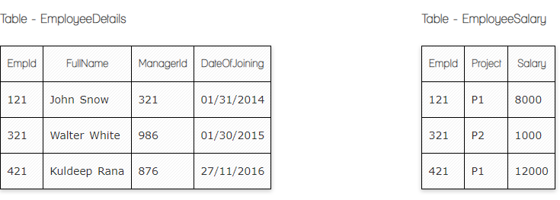

**Ques.1. Write a SQL query to fetch the count of employees working in project 'P1'.**

**Answer:**

**SELECT COUNT (EmpId)**

**FROM EmployeeSalary**

**WHERE Project=P1;**

**Ques.2. Write a SQL query to fetch employee names having salary greater than or equal to 5000 and less than or equal 10000.**

**Answer:**

**SELECT FullName**

**FROM EmployeeDetails**

**INNER JOIN EmployeeSalary**

**ON EmployeeDetails.EmpId=EmployeeSalary.EmpId**

**WHERE Salary>=’5000’ AND Sallary=<’10000’;**

**Ques.3. Write a SQL query to fetch count of employees sorted by project's count in descending order.**

**Answer:**

**SELECT Project COUNT(EmplId) EmpProjectCount**

**FROM EmployeeSalary**

**GROUP BY Project**

**ORDER BY Project DESC;**

**Ques.4. Write a query to fetch employee names and salary records. Return employee details even if the salary record is not present for the employee.**

**Answer:**

**SELECT FullName, Salary**

**FROM EmployeeDetails**

**LEFT JOIN EmployeeSalary**

**ON EmployeeDetails.EmpID= EmployeeSalary.EmpId;**

**Ques.5. Write a SQL query to create an empty table with ‘Test’ name.**

**Answer:**

**CREATE TABLE Test (**

**TesterID int,**

**FullName varchar(255),**

**Address varcar (255),**

**City varchar (255),**

**Country varchat (255),**

**);**

**Ques.6. Write a SQL query to delete an empty table with ‘Test’ name.**

**Answer:**

**DROP TABLE Test;**

**Ques.7. Write a SQL query to fetch all the Employees details from EmployeeDetails table who joined in Year 2016.**

**Answer:**

**SELECT \***

**FROM EmployeeDetails**

**WHERE YEAR (DateOfJoining)=2016;**

**Ques.8. Write a SQL query to insert new record to the EmployeeDetails table with any data.**

**Answer:**

**INSERT INTO EmployeeDetails**

**VALUE (521, Madonna, 888, 26/12/2018);**

**Ques.9. Write a SQL query to update EmployeeSalery table with setting Salary to 2000 for Project P2.**

**Answer:**

**UPDATE EmployeeSalary**

**SET Salary=2000**

**WHERE Project=P2;**

**Ques.10. Write a SQL query to right join both tables and draw the results.**

**Answer:**

**SELECT \***

**FROM EmployeeDetails**

**RIGHT JOIN EmployeeSalary ON EmployeeDetails.EmpId=EmployeeSalary.EmpId;**

|  |  |  |  |  |  |
| --- | --- | --- | --- | --- | --- |
| **EmpId** | **Project** | **Salary** | **FullName** | **ManajerId** | **DateOfJoining** |
| **121** | **P1** | **8000** | **John Snow** | **321** | **01/31/2014** |
| **321** | **P2** | **1000** | **Walter White** | **986** | **01/30/2015** |
| **421** | **P1** | **12000** | **Kuldeep Rana** | **876** | **27/11/2016** |

**Now take these two tables:**

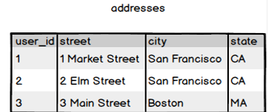

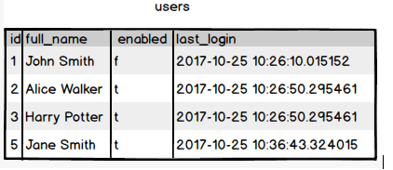

**Ques.11. Write a SQL query to fetch all users full_name from San Francisco.**

**Answer:**

**SELECT full_name**

**FROM users**

**INNER JOIN addresses**

**ON addresses.user_id=users.id**

**WHERE city= San Francisco;**

**Ques.12. Write a SQL query to fetch all users full_name, last_login who are enabled**

**Answer:**

**SELECT full_name, last_login**

**FROM users**

**WHERE enabled=t;**

**Ques.13. Write a SQL query to fetch all users full_name who are not from Main street**

**Answer:**

**SELECT full_name FROM users**

**INNER JOIN addresses ON users.id=addresses.user_id**

**WHERE STREET NOT IN(3Main Street);**

**Ques.14. Write a SQL query to fetch all users full_name who are from Main street or San Francisco**

**Answer:**

**SELECT full_name FROM users**

**INNER JOIN addresses ON users.id=addresses.user_id**

**WHERE street=’3Main Street’ OR city=San Francisco;**

**Ques.15. Write a SQL query to fetch user full_name who is equal to user_id from Boston (find user_id value in sub_query)**

**Answer:**

**SELECT full_name FROM users**

**WHERE id=**

**(SELECT user_id FROM addresses**

**WHERE city='Boston');**